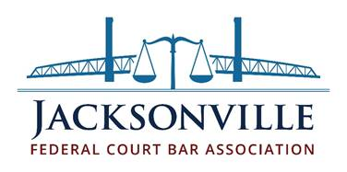

**BOARD MEMBER OATH**

I DO SOLEMNLY SWEAR THAT I AM DULY QUALIFIED TO HOLD OFFICE UNDER THE CHARTER AND BYLAWS OF THE JACKSONVILLE FEDERAL COURT BAR ASSOCIATION, AND THAT I WILL WELL AND FAITHFULLY PERFORM THE DUTIES OF THE OFFICE UPON WHICH I AM ABOUT TO ENTER, SO HELP ME GOD.