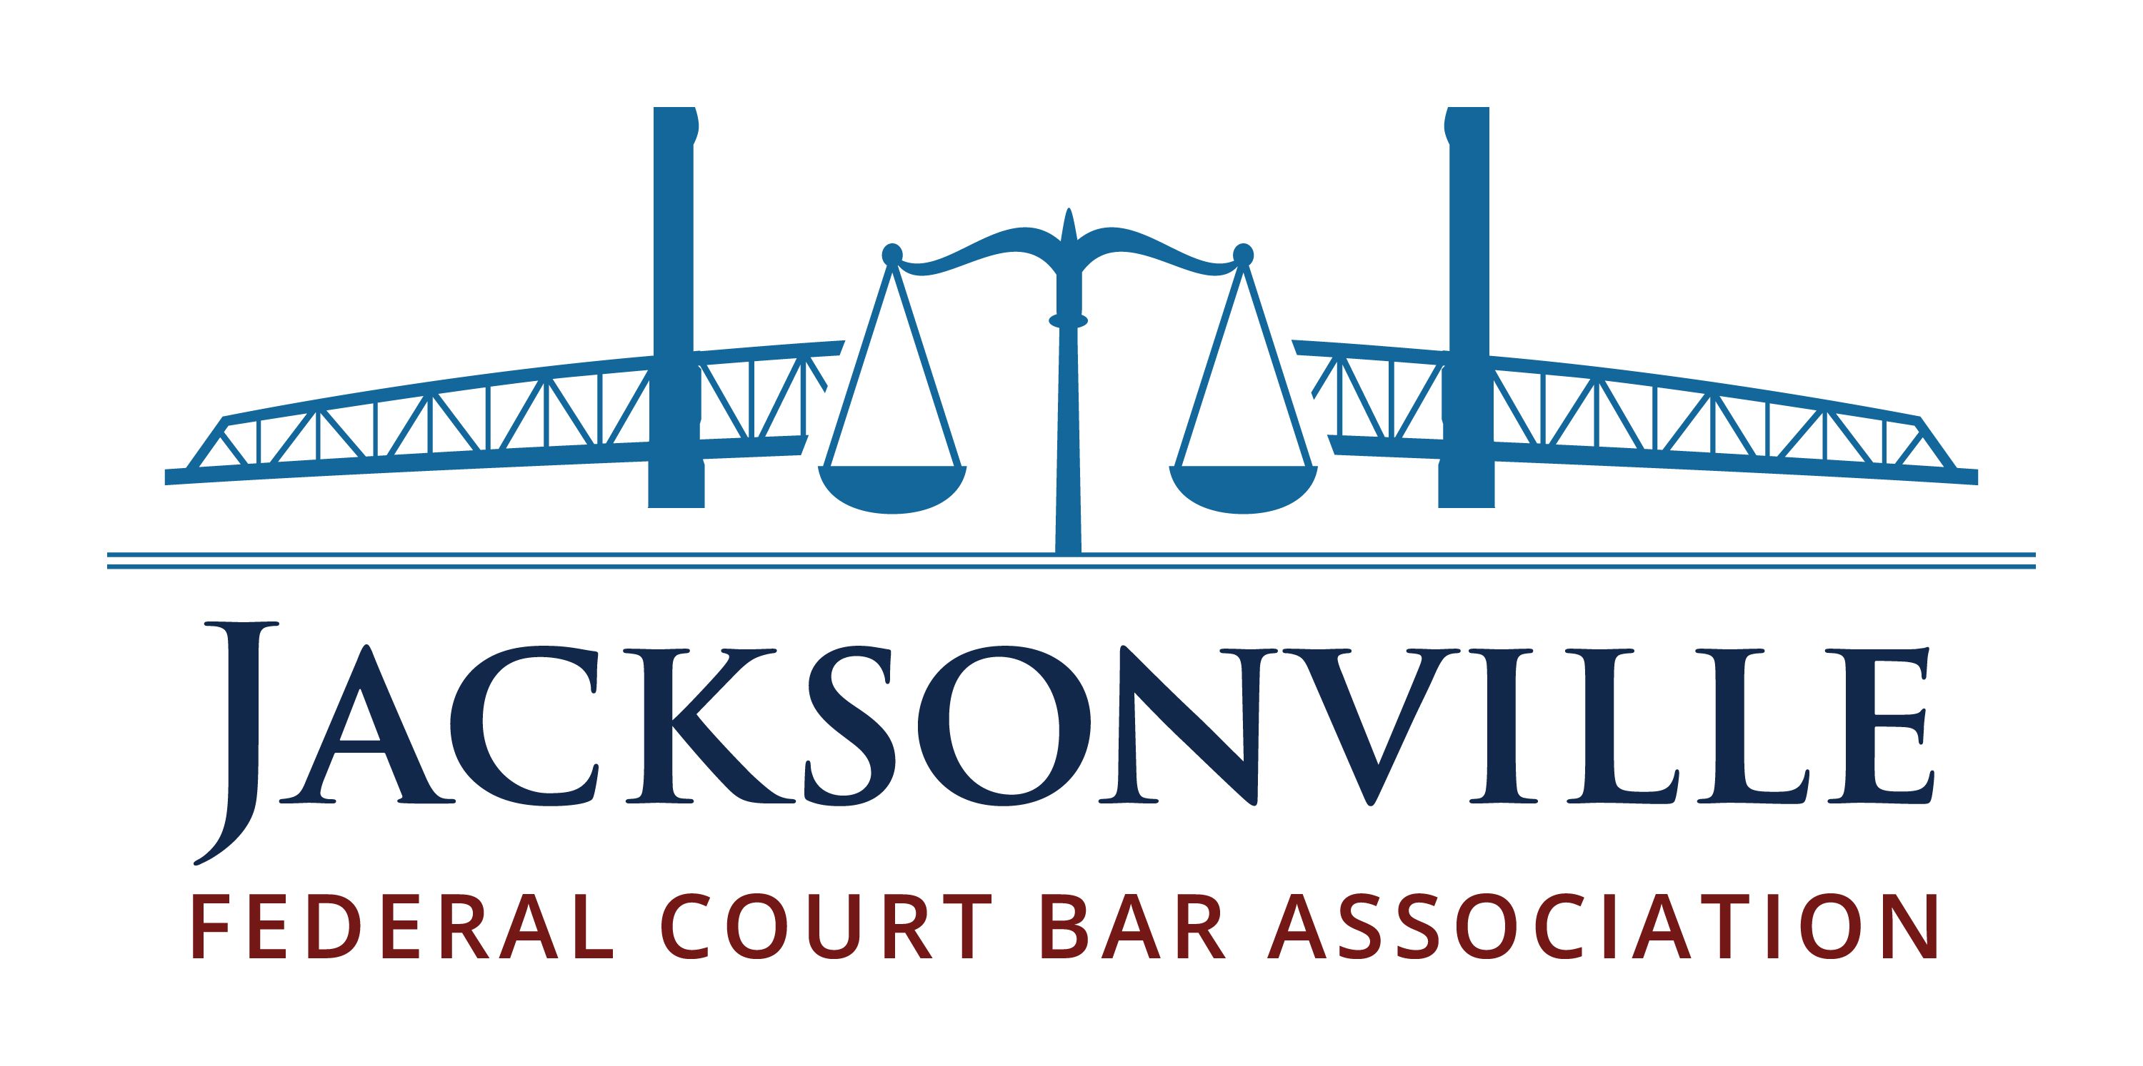
MEMBERSHIP STATEMENT
October 1, 2023 - September 30, 2024

Full Name:
Firm / Organization:
Practice Type:
Bar Admission Year:
Telephone:
E-Mail:
Address:

Submit your membership statement one of two ways:

(1) Visit us at www.jaxfedbar.org where you can
complete an online membership statement, pay your dues, register for upcoming events, and more!

OR

(2) Mail this form, and a check made payable to
“Jacksonville Federal Court Bar Association,” to
221 N. Hogan Street, Box #267, Jacksonville, FL 32202

Would you like to get federal court experience through the Court’s pro bono appointment program? Check this box and we will reach out to you with more information.

☑ Going Green: To reduce paper, the chapter sends notices of upcoming
events by e-mail only. We will not display your e-mail address to all
recipients or give the e-mail distribution list to other organizations.

COST

(please check one)

$ 125 General Membership

$ 75 Government Lawyers
Non-Profit Lawyers*

FREE First-Year Law Clerks
Judges

Fees are due September 30, 2023

Interested in joining mid-year?
We prorate dues so it’s never too late to join! For more information, email us at admin@jaxfedbar.org.

*The reduced rate is for Assistant United States Attorneys, Assistant Federal Defenders, Judicial Law Clerks (past their first year), Judicial Staff Attorneys, Office of the General Counsel Attorneys, and Legal Aid Attorneys. It is not for private attorneys serving on the CJA panel. Private lawyers who need a discount are welcome to contact us.

Membership fees are not deductible as charitable contributions for federal income tax purposes.

